 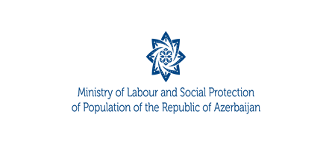

**1 April**

**2024**

**DRAFT**

**10:00 - 10:30**

**10:30 – 12:00**

**12:00 – 12:20**

**12:20 – 13:00**

**13:00 – 14:00**

проект: 25.11.2022

**Azerbaijan-Romania business forum**

**AGENDA**

**Venue:** *Four Seasons Hotel*

**Event language:** *English translation*

**Moderator: TBC**

**Registration**

**B2B**

**Opening speeches:**

**Mr. Sahil Babayev,** Minister of Labour and Social Protection of the Population of Republic of Azerbaijan

**Romanian side**

**Speeches:**

**Mr. Yusif Abdullayev,** Executive Director of the Export and Investment Promotion Agency of the Republic of Azerbaijan – AZPROMO

**Romanian side**

**Mr. Orkhan Mammadov,** Chairman of the Management Board of Small and Medium Business Development Agency of the Republic of Azerbaijan

**Romanian side**

**Lunch**